**Calculator Free**

**The Unit Circle, Radian Measure and Trigonometric Equations**

Time: 45 minutes

Total Marks: 45

Your Score: / 45



**Question One: [1, 2 = 3 marks]**

1. Explain what relationship radian measure represents.
2. Hence or otherwise explain what 1 radian looks like on a circle with radius 5 cm. Draw a diagram to assist your explanation.

**Question Two: [1, 2, 1, 2 = 6 marks]**

Express each of these angles as radians, in terms of π, leaving your answers as exact values.

1. 180˚ (c) 60˚
2. 210˚ (d) 330˚

**Question Three: [1, 1, 2, 2 = 6 marks]**

Express each of these angles in degrees, leaving answers in terms of π where necessary:

1.  (c) 
2.  (d) 

**Question Four: [1, 1 , 1, 1, 2, 2 = 8 marks]**

Use the unit circle diagram below to approximate the value of:

1. 
2. 
3. 
4. 
5. 
6. 

**Question Five: [1, 1, 1, 1, 1, 3 = 8 marks]**

Express each of the following as a simplified exact value:

1. 
2. 
3. 
4. 
5. 
6. 

**Question Six: [2, 2, 3, 3, 4 = 14 marks ]**

Solve each of the following trigonometric equations over the given domain.

1. 
2. 
3. 
4. 
5. 

**SOLUTIONS**

**Calculator Free**

**The Unit Circle, Radian Measure and Trigonometric Equations**

Time: 45 minutes

Total Marks: 45

Your Score: / 45



**Question One: [1, 2 = 3 marks]**

1. Explain what relationship radian measure represents.

The ratio between the arc length and the radius.



1. Hence or otherwise explain what 1 radian looks like on a circle with radius 5 cm. Draw a diagram to assist your explanation.

The sector drawn has radius 5cm and an arc length of 5 cm if the angle measure is 1 radian.

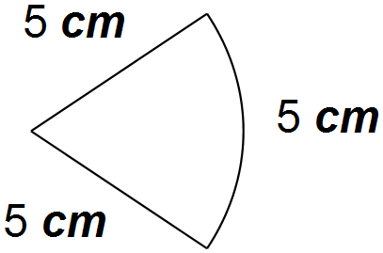



**Question Two: [1, 2, 1, 2 = 6 marks]**

Express each of these angles as radians, in terms of π, leaving your answers as exact values.

1. 180˚ (c) 60˚

 

1. 210˚ (d) 310˚

** **

**Question Three: [1, 1, 2, 2 = 6 marks]**

Express each of these angles in degrees, leaving answers in terms of π where necessary:

1.  (c) 

  

1.  (d) 

** **

**Question Four: [1, 1 , 1, 1, 2, 2 = 8 marks]**

Use the unit circle diagram below to approximate the value of:

1. 



1. 



1. 



1. 



1. 



1. 



**Question Five: [1, 1, 1, 1, 1, 3 = 8 marks]**

Express each of the following as a simplified exact value:

1. 



1. 



1. 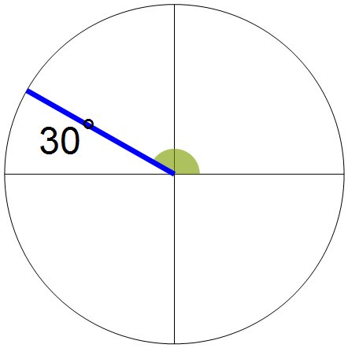



1. 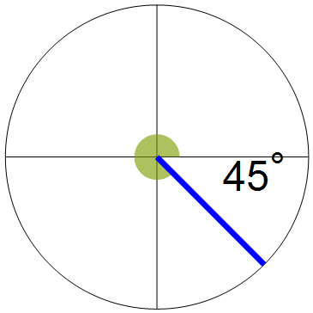



1. 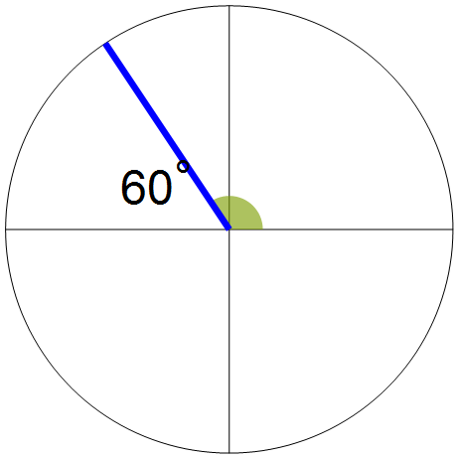



1. 

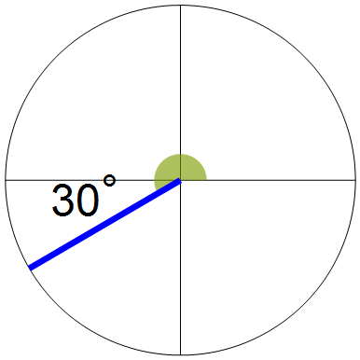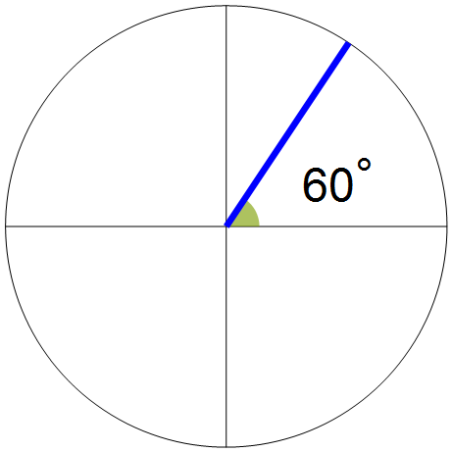

**Question Six: [2, 2, 3, 3, 4 = 14 marks ]**

Solve each of the following trigonometric equations over the given domain.

1. 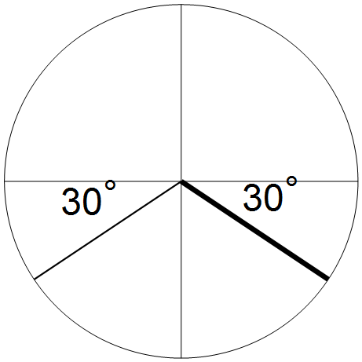





1. 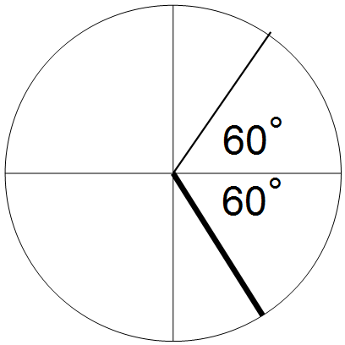





1. 

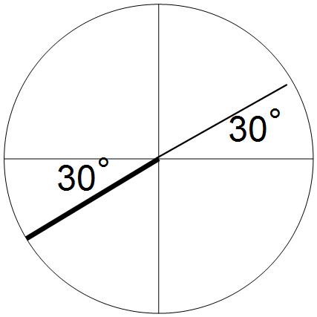



1. 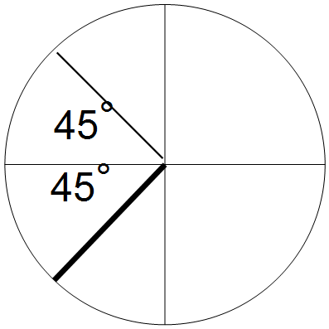



1. 